Lesson Plan Template (Revised 2018)
Elementary Years
Name: | Gagan Vaid

Grade | Kindergarten | Topic | Science – Is it Living?
Date | November 12, 2019 | Allotted Time | 30 minutes
STAGE 1: Desired Results

Cite sources used to develop this plan:
https://www.education.com/lesson-plan/living-and-nonliving-things/

Rationale: How is this lesson relevant at this time with these students? Why is it important?
Students will explore the difference between living and non-living observable features in their everyday lives. This lesson is important because it has students critically-think about what is living around them compared to what is not living in their surroundings.

Curriculum Connections: What Big Ideas (Understand,) Core and Curricular Competencies (Do), Content Standards (Know) does this lesson develop?
Understand
Big Ideas: Plants and animals have observable features.

Essential or Guiding Questions: What are some materials that are living and non- living in our surroundings?

Do
Core Competency (Communication, Creative and Critical Thinking, and Personal and Social Responsibility): Students will critically think in terms of comparing living features to non-living features. Personal and social responsibility is important during this lesson because students will be taking the knowledge from the lesson to embed it into their surroundings-by taking care of the environment, knowing which things are living and non-living. To care for the living/non-living materials.

Curricular Competencies:
Demonstrate curiosity and a sense of wonder about the world
Share observations and ideas orally
Express and reflect on personal experiences of place

Know
Content Standards: living things make changes to accommodate daily and seasonal cycles

First Peoples Principles of Learning:

Learning is holistic, reflexive, reflective, experiential, and relational (focused on connectedness, reciprocal relationships, and a sense of place). This principle is embedded in the lesson by learning about the school’s surroundings by observing living/non-living things around the school.

STAGE 2: Assessment Plan
Learning Intention:  What will students learn? | I will learn the difference between living and non-living materials within my surroundings.
Evidence of Learning:  How will students show their learning? | Students will show their learning by drawing their learning of what they think is living vs. non-living onto a chart.
Criteria:  What criteria will help students know how to be successful? | It will be guided by the teacher so, verbal instructions and step-by-step guidance by teacher will help students be successful through this lesson.

STAGE 3: Learning Plan

Resources, Material, and Preparation: What resources, materials, and preparation are required?
Living/Non -living chart paper, poster, student handout
Organizational/Management Strategies: (anything special to consider?)
Individual work at their desks
Lesson Development
Connect:  How will you introduce this lesson in a manner that engages students and activates their thinking? Activate or build background knowledge, capture interest, share learning intention. |  | Pacing  10 mins
- Teacher will introduce the topic by having students sit down on a circle and teacher provides a class poster where students observe to see which items are living and which items are non-living on the poster  - Teacher writes living/non-living materials on the chart paper | - Students will listen to teacher’s topic and learning intention about living/non-living materials  - Students will observe the poster and put their hand up to answer living vs. non-living items

Process: What steps and activities are you going to use to help students interact with new ideas, build understanding, acquire and practice knowledge, skills and/or attitudes? In what ways have you built-in guided practice? |  |  |  | Pacing
- Teacher will introduce the topic by having students sit down on a circle and teacher provides a class poster where students observe to see which items are living and which items are non-living on the poster  - Teacher writes living/non-living materials on the chart paper  - Teacher will direct students to work individually  - Teacher will hand out the cut/paste handout  - Teacher will guide partners to cut and paste the pictures to match living/non-living materials  - Teacher will have students’ hand in their finished handouts |  | - Students will listen to teacher’s topic and learning intention about living/non-living materials  - Students will observe the poster and put their hand up to answer living vs. non-living items  - Students will go to their desk and get out their supplies-glue, pencil, scissors  - Students will observe the pictures in the handout  - Students will cut and paste pictures onto the handout depending on what they think in terms of living/non-living materials  - Students will critically think in terms of what materials are living and what materials are non-living  - Students will hand in their finished handout to the teacher |  | 20 mins
Transform: How will students apply or practice their learning? Can they show or represent their learning in personalized ways? What are the choices for student tasks?
Students will apply their learning to the chart where they will draw their material as well to place into the handout. They can personalize their learning by coloring, drawing, and even writing about added materials of their own that they think are living/non-living.

Planning for diversity (adaptations, extensions, other): In what ways does the lesson meet the needs of diverse learners? How will you plan for students who have learning/behavior difficulties or require enrichment? |  |  |  | Pacing
Students need cut and paste onto the handout  Access | Students can do draw materials of their own.  Most |  | Students could present their findings to the class.  Few
Closure: How will you solidify the learning that has taken place and deepen the learning process? Refer back to the learning intention, connect to the next learning.
Students will solidify their learning by finding what materials are living and non-living when they go outside for lunch, recess, and during their own time. They can collect materials outside on their own time to gain a deeper understanding of living/non-living materials.
Reflection What was successful in this lesson? If taught again, what would you change to make this lesson even more successful and inclusive for diverse and exceptional students?

Just sample handout -handout is much more clear
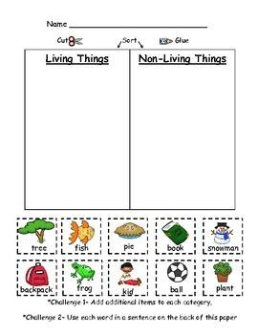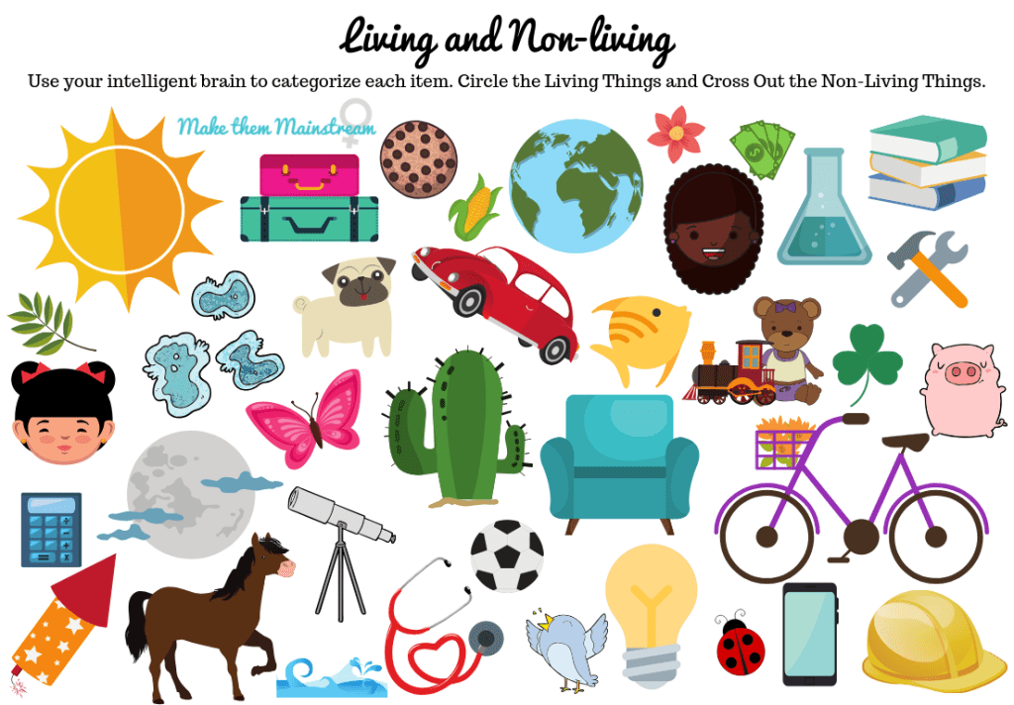

Lesson Plan Template (Revised 2018)
Elementary Years
Name: | Gagan Vaid

Grade | Kindergarten | Topic | Science and Applied Design, Skills, and Technologies – Is it Living?
Date | November 12, 2019 | Allotted Time | 25 minutes
STAGE 1: Desired Results

Cite sources used to develop this plan:
https://www.education.com/lesson-plan/living-and-nonliving-things/

Rationale: How is this lesson relevant at this time with these students? Why is it important?
Students will explore the difference between living and non-living observable materials in their everyday lives. This lesson is important because it takes students on a walk outside where they will pick up things that they think are living and non-living. Students will deepen their understanding of the difference between the two types of materials.

Curriculum Connections: What Big Ideas (Understand,) Core and Curricular Competencies (Do), Content Standards (Know) does this lesson develop?
Understand
Big Ideas: Plants and animals have observable features.

Essential or Guiding Questions: What are some materials that are living and non- living in our surroundings?

Do
Core Competency (Communication, Creative and Critical Thinking, and Personal and Social Responsibility): Students will critically think in terms of comparing living features to non-living features. Personal and social responsibility is important during this lesson because students will be taking the knowledge from the lesson to embed it into their surroundings-by taking care of the environment, knowing which things are living and non-living. To care for the living/non-living materials.

Curricular Competencies:
Demonstrate curiosity and a sense of wonder about the world
Share observations and ideas orally
Express and reflect on personal experiences of place

Know
Content Standards: living things make changes to accommodate daily and seasonal cycles

First Peoples Principles of Learning:

Learning is holistic, reflexive, reflective, experiential, and relational (focused on connectedness, reciprocal relationships, and a sense of place). This principle is embedded in the lesson by learning about the school’s surroundings by observing living/non-living things around the school. This lesson takes you to the outdoors to experience inquiry-based learning on living/non-living materials.

STAGE 2: Assessment Plan
Learning Intention:  What will students learn? | I will learn the difference between living and non-living materials within my surroundings.
Evidence of Learning:  How will students show their learning? | Students will show their learning by drawing what they found outside and answering the questions-can they grow? Can it breathe? Is it living?
Criteria:  What criteria will help students know how to be successful? | It will be guided by the teacher so, verbal instructions and step-by-step guidance by teacher will help students be successful through this lesson especially when outdoors.

STAGE 3: Learning Plan

Resources, Material, and Preparation: What resources, materials, and preparation are required?
Paper bags, pencils, handout,
Organizational/Management Strategies: (anything special to consider?)
Work in partners (groups of two when outside)
Lesson Development
Connect:  How will you introduce this lesson in a manner that engages students and activates their thinking? Activate or build background knowledge, capture interest, share learning intention. |  | Pacing
- Teacher will introduce the topic by having re-visiting the chart students made on living/non-living materials from the last lesson  - Teacher will ask the questions- what is living at home? What is non-living in this classroom? What else can we add to this chart paper | - Students will listen to teacher’s questions on living/non-living materials  - Students will think about the questions and put their hand up to answer living vs. non-living materials that they can add to the chart paper | 5 minutes

Process: What steps and activities are you going to use to help students interact with new ideas, build understanding, acquire and practice knowledge, skills and/or attitudes? In what ways have you built-in guided practice? |  |  |  | Pacing
- Teacher will have students sit in a circle on the carpet  - Teacher will introduce the topic by having re-visiting the chart students made on living/non-living materials from the last lesson  - Teacher will ask the questions- what is living at home? What is non-living in this classroom? What else can we add to this chart paper  - Teacher will give clear instructions on our nature walk as a class  - Teacher will direct students in a line-up  - Teacher will give them 1 paper bag per student  - Teacher will place students in partners  - Teacher will give out the handout and explain activity  - Teacher will provide help to those who need  - Teacher will close the lesson by asking students to volunteer what they drew from outside |  | - Students will sit on the carpet and listen to teacher’s introduction on the lesson  - Students will listen to teacher’s questions on living/non-living materials  - Students will think about the questions and put their hand up to answer living vs. non-living materials that they can add to the chart paper  - Students will put on their warm jackets and follow in a line-up to go outside  - Students will grab a paper bag and walk with a partner following the teacher in a lineup  - Students will pick up materials that are non-living and draw living materials  - After 10 minutes we will come inside and students will take off their jackets  - Students will go to their own desks and draw what they found  - Students will answer the questions if it is growing, alive, and breathe  - Students will hand in the handout to teacher |  | 20 mins
Transform: How will students apply or practice their learning? Can they show or represent their learning in personalized ways? What are the choices for student tasks?
Students will apply their learning to their handout where they will draw their material from the paper bag. They can personalize their learning by coloring, drawing, and even writing about what material they had in the bag.

Planning for diversity (adaptations, extensions, other): In what ways does the lesson meet the needs of diverse learners? How will you plan for students who have learning/behavior difficulties or require enrichment? |  |  |  | Pacing
Students need to pick up materials from outside.  Access | Students can do draw or write what materials they found outside.  Most |  | Students could present their findings to the class.  Few
Closure: How will you solidify the learning that has taken place and deepen the learning process? Refer back to the learning intention, connect to the next learning.
Students will solidify their learning by finding what materials outside are living and non-living when they go outside for lunch, recess, and during their own time. They can collect materials outside on their own time to gain a deeper understanding of living/non-living materials. They can also bring home materials they found and share with their family on their learning experience.
Reflection What was successful in this lesson? If taught again, what would you change to make this lesson even more successful and inclusive for diverse and exceptional students?

Just sample handout -handout is much more clear

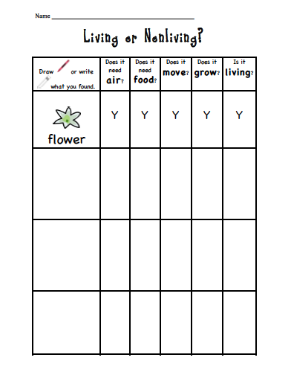

Lesson Plan Template (Revised 2018)
Elementary Years
Name: | Gagan Vaid

Grade | Kindergarten | Topic | Science and Applied Design, Skills, and Technologies – Is it Living?
Date | November 12, 2019 | Allotted Time | 30 minutes
STAGE 1: Desired Results

Cite sources used to develop this plan:
https://www.teacherspayteachers.com/FreeDownload/Living-and-Nonliving-Sort-Freebie-613683

Rationale: How is this lesson relevant at this time with these students? Why is it important?
Students will explore the difference between living and non-living observable materials in their everyday lives. This lesson is important because it takes students on a walk outside where they will pick up things that they think are living and non-living. Students will deepen their understanding of the difference between the two types of materials.

Curriculum Connections: What Big Ideas (Understand,) Core and Curricular Competencies (Do), Content Standards (Know) does this lesson develop?
Understand
Big Ideas: Plants and animals have observable features.

Essential or Guiding Questions: What are some materials that are living and non- living in our surroundings?

Do
Core Competency (Communication, Creative and Critical Thinking, and Personal and Social Responsibility): Students will critically think in terms of comparing living features to non-living features. Personal and social responsibility is important during this lesson because students will be taking the knowledge from the lesson to embed it into their surroundings-by taking care of the environment, knowing which things are living and non-living. To care for the living/non-living materials.

Curricular Competencies:
Demonstrate curiosity and a sense of wonder about the world
Share observations and ideas orally
Express and reflect on personal experiences of place

Know
Content Standards: living things make changes to accommodate daily and seasonal cycles

First Peoples Principles of Learning:

Learning is holistic, reflexive, reflective, experiential, and relational (focused on connectedness, reciprocal relationships, and a sense of place). This principle is embedded in the lesson by learning about the school’s surroundings by observing living/non-living things in the classroom. This lesson takes you around the class to understand what materials are living and non-living.

STAGE 2: Assessment Plan
Learning Intention:  What will students learn? | I will learn the difference between living and non-living materials within my classroom.
Evidence of Learning:  How will students show their learning? | Students will show their learning by cutting a pasting picture that are non-living and living onto the living/non-living handout.
Criteria:  What criteria will help students know how to be successful? | This will be an summative assessment as where students will complete their handout based on their understanding.

STAGE 3: Learning Plan

Resources, Material, and Preparation: What resources, materials, and preparation are required?
Classroom objects, Pencil, glue, scissors, pencil crayons, handout,
Organizational/Management Strategies: (anything special to consider?)
Work independently
Lesson Development
Connect:  How will you introduce this lesson in a manner that engages students and activates their thinking? Activate or build background knowledge, capture interest, share learning intention. |  | Pacing
- Teacher will review the lessons from before connecting to today’s lesson  - Teacher will walk around the classroom and pick up objects and students will guess if it is living or non-living | - Students will listen to teacher’s questions on living/non-living materials  - Students will think about the questions and put their hand up to answer living vs. non-living materials | 5 minutes

Process: What steps and activities are you going to use to help students interact with new ideas, build understanding, acquire and practice knowledge, skills and/or attitudes? In what ways have you built-in guided practice? |  |  |  | Pacing
- Teacher will review the lessons from before connecting to today’s lesson  - Teacher will walk around the classroom and pick up objects and students will guess if it is living or non-living  - Teacher will explain handout activity  - Teacher will have students work independently  - Teacher will have students share their learning in a sharing circle to close off the lessons |  | - Students will listen to teacher’s questions on living/non-living materials  - Students will think about the questions and put their hand up to answer living vs. non-living materials  - Students will listen to instructions on the lesson  - Students will grab materials and work independently at their desk  - Students will share their learning in a sharing circle |  | 20 mins
Transform: How will students apply or practice their learning? Can they show or represent their learning in personalized ways? What are the choices for student tasks?
Students will apply their learning to their handout where they will cut and paste to their handout. They can personalize their learning by coloring and further drawing other materials they think are living/non-living.

Planning for diversity (adaptations, extensions, other): In what ways does the lesson meet the needs of diverse learners? How will you plan for students who have learning/behavior difficulties or require enrichment? |  |  |  | Pacing
Students need to complete handout  Access | Students can discuss what they learned in the sharing circle  Most |  | Students could present their handout to the class  Few
Closure: How will you solidify the learning that has taken place and deepen the learning process? Refer back to the learning intention, connect to the next learning.
Students will solidify their learning by finding what materials outside are living and non-living when they go outside for lunch, recess, and during their own time. They can collect materials outside on their own time to gain a deeper understanding of living/non-living materials. They can also bring home materials they found and share with their family on their learning experience.
Reflection What was successful in this lesson? If taught again, what would you change to make this lesson even more successful and inclusive for diverse and exceptional students?

