Lesson Plan Template (Revised 2018)
Elementary Years
Name: | Gagan

Grade | Kindergarten | Topic | Fine Arts and English Language Arts
Date | November 12, 2019 | Allotted Time | 30 minutes
STAGE 1: Desired Results

Cite sources used to develop this plan:
https://kinderart.com/art-lessons/drawing/a-drawing-adventure/

Rationale: How is this lesson relevant at this time with these students? Why is it important?
This lesson is important because it uses imagination to create their own imaginary winter adventure. As well, it makes the students think about where they want their adventure to be and how it should be for them. This is could be a stress reliever for some students and a way to relax them as music is present in the background of this activity.

Curriculum Connections: What Big Ideas (Understand,) Core and Curricular Competencies (Do), Content Standards (Know) does this lesson develop?
Understand
Big Ideas: People create art to express who they are as individuals and community.
Essential or Guiding Questions: What does your imaginary adventure look like? Explain why?
Do
Core Competency (Communication, Creative and Critical Thinking, and Personal and Social Responsibility): Creative- students will create an adventure using pencil crayons and ideas of their own
Critical Thinking- this activity will have students thinking about their own adventure and having them explain the images in their picture
Curricular Competencies: Create artistic works collaboratively and as an individual, using ideas inspired by imagination, inquiry, experimentation, ad purposeful play
Know
Content Standards: symbolism as expressions of meaning

First Peoples Principles of Learning:

Learning is holistic, reflexive, reflective, experiential, and relational (focused on connectedness, on reciprocal relationships, and a sense of place). This activity has embedded First Nations Principles because the learning takes place through a reflective lens of the student’s life. The students use imagination and must find a place they see as an adventure to create their own personalized place.

STAGE 2: Assessment Plan
Learning Intention:  What will students learn? | I will learn how to create my own imaginary adventure.
Evidence of Learning:  How will students show their learning? | Students will show their learning by creating their own imaginary adventure with images that relate to their adventure. They will then explain to a partner why they chose the images in their adventure.
Criteria:  What criteria will help students know how to be successful? | The criteria which will make them successful is an image of imaginary adventure, completion of the image, and participation of the pair/share at the end of the lesson.

STAGE 3: Learning Plan

Resources, Material, and Preparation: What resources, materials, and preparation are required?
White blank paper, pencil, pencil crayons, clipboard or hard textbook
Organizational/Management Strategies: (anything special to consider?)
Students will be working individually for this art activity. I will have them sit anywhere outside for this activity.

Lesson Development
Connect:  How will you introduce this lesson in a manner that engages students and activates their thinking? Activate or build background knowledge, capture interest, share learning intention. |  | Pacing
- Teacher will state learning intention  - Teacher will tell students to close their eyes  - Teacher will ask them questions inside about their personal adventure to get them thinking about the activity – for example, where are you going on your adventure?” “How will you get there?” “Who will you see when you arrive?” “What will you on your adventure?”  - Teacher will tell students to open their eyes and tell her what they saw | - Student will listen to learning intention for the lesson  - Students will close their eyes and imagine their own adventure  - Students will listen to these questions and gather ideas- where are you going on your adventure?” “How will you get there?” “Who will you see when you arrive?” “What will you on your adventure?”  - Students will open their eyes and state what they saw | 10 minutes

Process: What steps and activities are you going to use to help students interact with new ideas, build understanding, acquire and practice knowledge, skills and/or attitudes? In what ways have you built-in guided practice? |  |  |  | Pacing
Teacher will  - Teacher will state learning intention for the lesson  - Teacher will tell students to stay at their desks for the activity  - Teacher will tell students to close their eyes for a few minutes as they imagine their adventure  - Teacher will ask 4 questions and also give ideas of her own with the questions-where are you going on your adventure?” “How will you get there?” “Who will you see when you arrive?” “What will you on your adventure?”  - Teacher will tell students to open their eyes and tell her what they saw  - Teacher will explain the activity which will be based outside and there will be boundaries  - Teacher will ask if they have any questions/concerns  - Teacher will have students grab materials and bundle up for outside  - Teacher will help students bundle up and line up for outside  - Teacher will explain the boundaries for outside again as a reminder  - Teacher will have students stay for 10-15 minutes and have them come inside to color- Teacher will give a 5-minute warning  - Teacher will have students do a pair/share once they are done to explain why and what they drew for their adventure |  | Students will  - Student will listen to learning intention for the lesson  - Students will stay at their desks seated  - Students will close their eyes and imagine their own adventure  - Students will listen to teacher’s ideas and questions - where are you going on your adventure?” “How will you get there?” “Who will you see when you arrive?” “What will you on your adventure?”  - Students will not respond but instead imagine their adventure  - Students will open their eyes and state what they saw aloud  - Students will listen to activity and instructions  - Students will grab all materials and bundle up for outside  - Students will stay within boundaries of the school and where teacher can see them  - Students will stay 10-15 minutes outside sitting/standing anywhere they feel comfortable, listen to time warnings outside  - Students will do a pair/share once they are done to explain why and what they drew for their adventure |  | 30 minutes
Transform: How will students apply or practice their learning? Can they show or represent their learning in personalized ways? What are the choices for student task?
Students will apply or practice their learning by responding to the teacher’s questions about their adventure. They can show their learning by incorporating their images on a blank paper of their own adventure. The choices for student task are they can draw and color anything (needs to be appropriate), and when they go outside they sit, stand, walk around within boundaries to gain ideas (does not have to be real or something outside either).

Planning for diversity (adaptations, extensions, other): In what ways does the lesson meet the needs of diverse learners? How will you plan for students who have learning/behavior difficulties or require enrichment? |  |  |  | Pacing
Students need to  be able to create their personalized adventure  Access | Students can do  participate in the adventure questions after they have opened their eyes  Most |  | Students could do  Come up to the class with their partner and talk about their partner’s adventure instead of their own-showing what they learned about their partner.  Few
Closure: How will you solidify the learning that has taken place and deepen the learning process? Refer back to the learning intention, connect to the next learning.

Students will be able to solidify their learning with the pair/share as they explain why and what they drew for their adventure. They can also present to the class of what their partner’s adventure looks like -showing what they learned about their partner’s adventure.
Reflection What was successful in this lesson? If taught again, what would you change to make this lesson even more successful and inclusive for diverse and exceptional students?
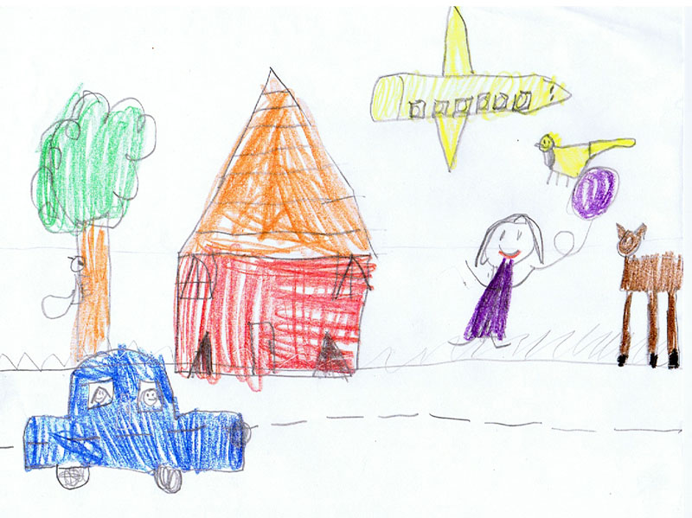

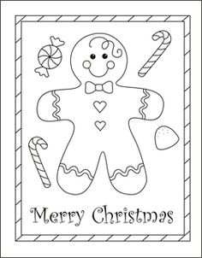
Lesson Plan Template (Revised 2018)
Elementary Years
Name: | Gagan

Grade | Kindergarten | Topic | Fine Arts and English Language Arts
Date | November 12, 2019 | Allotted Time | 30 minutes
STAGE 1: Desired Results

Cite sources used to develop this plan:
https://www.teacherspayteachers.com/

Rationale: How is this lesson relevant at this time with these students? Why is it important?
This lesson is important because Christmas is coming up! I want students to celebrate the holiday by creating cards for their loved ones to give on Christmas. This lesson uses creativity skills as students write and draw according to them. They take initiative in creating cards of their own for the holidays.

Curriculum Connections: What Big Ideas (Understand,) Core and Curricular Competencies (Do), Content Standards (Know) does this lesson develop?
Understand
Big Ideas: People create art to express who they are as individuals and community., People connect to others and share ideas through the arts.
Essential or Guiding Questions: How do I personally express my gratitude towards my loved ones?
Do
Core Competency (Communication, Creative and Critical Thinking, and Personal and Social Responsibility): Creative- students will be thinking how to personalize their cards for their loved ones- this requires creativity as students must think of ways to express themselves through a holiday card.

Curricular Competencies: Create artistic works collaboratively and as an individual, using ideas inspired by imagination, inquiry, experimentation, ad purposeful play
Know
Content Standards: symbolism as expressions of meaning

First Peoples Principles of Learning:

Learning is holistic, reflexive, reflective, experiential, and relational (focused on connectedness, reciprocal relationships, and a sense of place). This activity has embedded First Nations Principles because the learning takes place through a relational lens of the student’s life. The students use creative skills to connect with their loved ones.

STAGE 2: Assessment Plan
Learning Intention:  What will students learn? | I will learn how to create a personalized Christmas card.
Evidence of Learning:  How will students show their learning? | Students will show their learning by creating their own personalized Christmas cards with images and writing of their own.
Criteria:  What criteria will help students know how to be successful? | The criteria which will make them successful are the completion of their card and participation during the question/share hook.

STAGE 3: Learning Plan

Resources, Material, and Preparation: What resources, materials, and preparation are required?
Christmas template cards, pencil, pencil crayons/crayons, Christmas book
Organizational/Management Strategies: (anything special to consider?)
Students will be working individually for this art activity. I will have them sit anywhere in the classroom for this activity.

Lesson Development
Connect:  How will you introduce this lesson in a manner that engages students and activates their thinking? Activate or build background knowledge, capture interest, share learning intention. |  | Pacing
- Teacher will state learning intention  - Teacher will read a Christmas book from the shelf (The Grinch Stole Christmas preferably)  - Teacher will ask students what holidays they celebrate; do they celebrate Christmas and what they do during Christmas Day | - Student will listen to learning intention for the lesson  - Students will answer questions regarding Christmas and holidays in general | 10 minutes

Process: What steps and activities are you going to use to help students interact with new ideas, build understanding, acquire and practice knowledge, skills and/or attitudes? In what ways have you built-in guided practice? |  |  |  | Pacing
Teacher will  - Teacher will state learning intention  - Teacher will read a Christmas book from the shelf (The Grinch Stole Christmas preferably)  - Teacher will ask students what holidays they celebrate; do they celebrate Christmas and what they do during Christmas Day  - Teacher will explain activity- Christmas Cards  - Teacher will handout Christmas card templates  - Teacher will close the lesson with students sharing their own cards in a circle |  | Students will  - Student will listen to learning intention for the lesson  - Students will answer questions regarding Christmas and holidays in general  - Students will listen to the explanation of the activity  - Students will choose one of the Christmas templates  - Students will create their own card  - Students will share in the sharing circle  - Students will take home their card |  | 20 minutes
Transform: How will students apply or practice their learning? Can they show or represent their learning in personalized ways? What are the choices for student task?
Students will apply or practice their learning by responding to the teacher’s questions about Christmas/holidays. They can show their learning by incorporating their images and writing on the card. The choices for student task are they can draw and color anything (needs to be appropriate) relating to Christmas or another holiday if they do not celebrate Christmas.

Planning for diversity (adaptations, extensions, other): In what ways does the lesson meet the needs of diverse learners? How will you plan for students who have learning/behavior difficulties or require enrichment? |  |  |  | Pacing
Students need to  be able to create their personalized card  Access | Students can do  participate in the Christmas/holiday discussion  Most |  | Students could do  Make a card on a different holiday that they celebrate if they do not celebrate Christmas  Also, can make more than one card  Few
Closure: How will you solidify the learning that has taken place and deepen the learning process? Refer back to the learning intention, connect to the next learning.

Students will be able to solidify their learning by presenting during the sharing circle of what they draw and wrote o their card and what the card means to them. They can also bring the card home right after they have completed it and discuss to their family how they personalized the card.
Reflection What was successful in this lesson? If taught again, what would you change to make this lesson even more successful and inclusive for diverse and exceptional students?

Lesson Plan Template (Revised 2018)
Elementary Years
Name: | Gagan

Grade | Kindergarten | Topic | Fine Arts
Date | November 12, 2019 | Allotted Time | 30 minutes
STAGE 1: Desired Results

Cite sources used to develop this plan:
https://www.teacherspayteachers.com/
https://www.youtube.com/watch?v=3PgNPc-iFW8

Rationale: How is this lesson relevant at this time with these students? Why is it important?
This lesson is important because Christmas is coming up! I want students to celebrate the holiday by creating collage ornament plates of their own. This lesson uses creativity skills as students create their very own ornament to place on their tree. They take initiative in creating ornaments of their own for the holidays.

Curriculum Connections: What Big Ideas (Understand,) Core and Curricular Competencies (Do), Content Standards (Know) does this lesson develop?
Understand
Big Ideas: People create art to express who they are as individuals and community; People connect to others and share ideas through the arts.
Essential or Guiding Questions: How do I decorate my tree in a personalized way?
Do
Core Competency (Communication, Creative and Critical Thinking, and Personal and Social Responsibility): Creative- students will be thinking how to personalize their ornament to take home- this requires creativity as students must think of ways to help decorate in their own way

Curricular Competencies: Create artistic works collaboratively and as an individual, using ideas inspired by imagination, inquiry, experimentation, ad purposeful play
Know
Content Standards: symbolism as expressions of meaning

First Peoples Principles of Learning:

Learning is holistic, reflexive, reflective, experiential, and relational (focused on connectedness, reciprocal relationships, and a sense of place). This activity has embedded First Nations Principles because the learning takes place through a relational lens of the student’s life. The students use creative skills to connect with their loved ones.

STAGE 2: Assessment Plan
Learning Intention:  What will students learn? | I will learn how to create a personalized ornament to decorate for the holidays.
Evidence of Learning:  How will students show their learning? | Students will show their learning by creating their own personalized ornament with a paper plate, tissue paper, and glue.
Criteria:  What criteria will help students know how to be successful? | The criteria which will make them successful is the completion of their ornament, and participation through the Santa Says game guided by Teacher.

STAGE 3: Learning Plan

Resources, Material, and Preparation: What resources, materials, and preparation are required?
pencil, pencil crayons/crayons, string, paper plate, glue, tissue paper, glitter
Organizational/Management Strategies: (anything special to consider?)
Students will be working individually for this art activity.

Lesson Development
Connect:  How will you introduce this lesson in a manner that engages students and activates their thinking? Activate or build background knowledge, capture interest, share learning intention. |  | Pacing
- Teacher will state learning intention  - Teacher will introduce the game Santa Says  - Teacher will have students do the actions as she guides them through the actions  - Teacher will have students take turns being Santa | - Student will listen to learning intention for the lesson  - Students will listen to instructions of the game  - Students will copy the actions of the Teacher  - Students will take turns being Santa and coming up with their own ideas | 5-10 minutes

Process: What steps and activities are you going to use to help students interact with new ideas, build understanding, acquire and practice knowledge, skills and/or attitudes? In what ways have you built-in guided practice? |  |  |  | Pacing
Teacher will  - Teacher will state learning intention  - Teacher will introduce the game Santa Says  - Teacher will have students do the actions as she guides them through the actions  - Teacher will have students take turns being Santa  - Teacher will have students sit on the carpet and will explain the next activity  - Teacher will hand out supplies  - Teacher will close the lesson with a sing-along clip called Jingle Bells |  | Students will  - Student will listen to learning intention for the lesson  - Students will listen to instructions of the game  - Students will copy the actions of the Teacher  - Students will take turns being Santa and coming up with their own ideas  - Students will sit back on the carpet  - Students will listen to instructions of the art activity  - Students will work independently on their ornament  - Students will listen to the song and join into the sing-along |  | 20 minutes
Transform: How will students apply or practice their learning? Can they show or represent their learning in personalized ways? What are the choices for student task?
Students will apply or practice their learning through ornament activity. They will personalize their ornament tin way they want through the provided materials. The choice for student tasks is if they do not celebrate Christmas they can make an ornament symbolizing a holiday they do celebrate.

Planning for diversity (adaptations, extensions, other): In what ways does the lesson meet the needs of diverse learners? How will you plan for students who have learning/behavior difficulties or require enrichment? |  |  |  | Pacing
Students need to  be able to create their personalized ornament  Access | Students can do  participate in Santa Says by being the Santa  Most |  | Students could do  Make an ornament on a different holiday that they celebrate if they do not celebrate Christmas  Few
Closure: How will you solidify the learning that has taken place and deepen the learning process? Refer back to the learning intention, connect to the next learning.

Students will be able to solidify their learning by sharing with their family the ornament they will be bringing home in the end. Students will also apply their learning at home by decorating their home for the holidays by making art rather than buying decorations for the holidays.
Reflection What was successful in this lesson? If taught again, what would you change to make this lesson even more successful and inclusive for diverse and exceptional students?

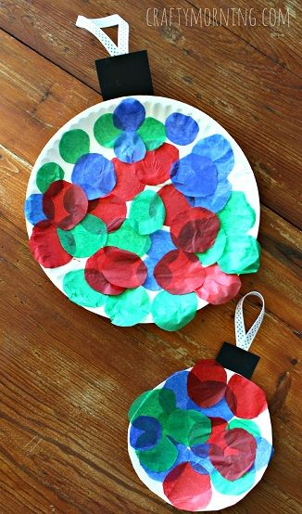
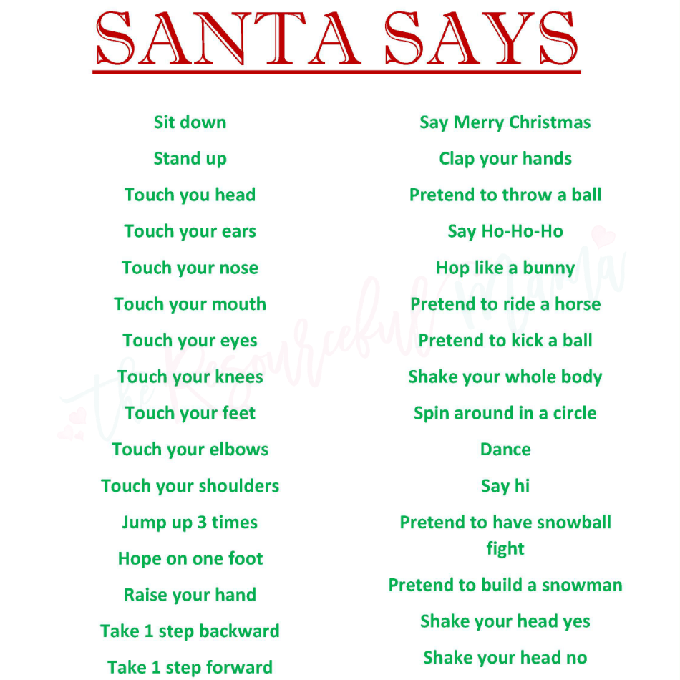

Lesson Plan Template (Revised 2018)
Elementary Years
Name: | Gagan

Grade | Kindergarten | Topic | Fine Arts and Science
Date | November 12, 2019 | Allotted Time | 30 minutes
STAGE 1: Desired Results

Cite sources used to develop this plan:

Rationale: How is this lesson relevant at this time with these students? Why is it important?
This lesson is important because Christmas is coming up! What better way to end the school year by baking cookies. This lesson is relevant because it combines team-work skills, communication/social skills, and it can be used in everyday life.

Curriculum Connections: What Big Ideas (Understand,) Core and Curricular Competencies (Do), Content Standards (Know) does this lesson develop?
Understand
Big Ideas: People create art to express who they are as individuals and community; People connect to others and share ideas through the arts
Essential or Guiding Questions: How do I follow instructions to bake cookies?
Do
Core Competency (Communication, Creative and Critical Thinking, and Personal and Social Responsibility): Communication- students will be working together to create one big batch of cookies. Personal and Social Responsibility- students will incorporate this lesson into their everyday lives by baking cookies and teaching their family how to bake cookies

Curricular Competencies: Create artistic works collaboratively and as an individual, using ideas inspired by imagination, inquiry, experimentation, ad purposeful play
Know
Content Standards: symbolism as expressions of meaning

First Peoples Principles of Learning:

Learning is holistic, reflexive, reflective, experiential, and relational (focused on connectedness, reciprocal relationships, and a sense of place). This activity has embedded First Nations Principles because the learning takes place through a relational lens of the student’s life. The students use creative skills to connect with their classroom community.

STAGE 2: Assessment Plan
Learning Intention:  What will students learn? | I will learn how to follow instructions and bake cookies as a class.
Evidence of Learning:  How will students show their learning? | Students will show their learning by participating in baking cookies.
Criteria:  What criteria will help students know how to be successful? | The criteria which will make them successful is through formative assessment by observing the participation of students following the steps in front of teacher.

STAGE 3: Learning Plan

Resources, Material, and Preparation: What resources, materials, and preparation are required?
Cookie mix, water, cookie ingredients, cookie sheet and bowl, oven cookie instructions, bingo cards
Organizational/Management Strategies: (anything special to consider?)
Students will be working together as a class.

Lesson Development
Connect:  How will you introduce this lesson in a manner that engages students and activates their thinking? Activate or build background knowledge, capture interest, share learning intention. |  | Pacing
- Teacher will state learning intention  - Teacher will introduce the game Santa Says  - Teacher will have students do the actions as she guides them through the actions  - Teacher will have students take turns being Santa | - Student will listen to learning intention for the lesson  - Students will listen to instructions of the game  - Students will copy the actions of the Teacher  - Students will take turns being Santa and coming up with their own ideas | 5-10 minutes

Process: What steps and activities are you going to use to help students interact with new ideas, build understanding, acquire and practice knowledge, skills and/or attitudes? In what ways have you built-in guided practice? |  |  |  | Pacing
Teacher will  - Teacher will state learning intention  - Teacher will introduce Christmas Bingo  - Teacher will guide student’s through Christmas Bingo  - Teacher will introduce baking cookies  - Teacher will have students sit in a circle and explain instructions  - Teacher will put on Christmas music in the background  - Teacher will have students take turns mixing the bowl and placing ingredients into the bowl  - Teacher will place cookies in the oven  - Teacher will give out cookies as the closure and have students answer what they think about the cookies |  | Students will  - Student will listen to learning intention for the lesson  - Students will wash hands  - Students will listen to instructions of the game  - Students will be given bingo cards and place buttons on the ones the Teacher calls out  - Students will take turns pouring in ingredients in the circle and taking turns mixing  - Students will place cookies onto the sheet  - Students will get 2 cookies each and answer what they think about the cookies |  | 20-25 minutes
Transform: How will students apply or practice their learning? Can they show or represent their learning in personalized ways? What are the choices for student tasks?
Students will apply or practice their learning by taking turns following instructions of baking cookies. They will personalize their learning by taking home the cookies and creating their own batch of cookies they want to make. The choices for student task is to either be the mixer or the pourer of ingredients.

Planning for diversity (adaptations, extensions, other): In what ways does the lesson meet the needs of diverse learners? How will you plan for students who have learning/behavior difficulties or require enrichment? |  |  |  | Pacing
Students need to  be able to help to make cookies  Access | Students can do  participate in sharing what they learned from the lesson  Most |  | Students could do  Making their own cookies at home with their family  Few
Closure: How will you solidify the learning that has taken place and deepen the learning process? Refer back to the learning intention, connect to the next learning.

Students will be able to solidify their learning by sharing with their family the cookies they made. Students will also apply their learning at home by baking cookies with their families if they want.
Reflection What was successful in this lesson? If taught again, what would you change to make this lesson even more successful and inclusive for diverse and exceptional students?

